

AMERICAN INTERNATIONAL UNIVERSITY-BANGLADESH (AIUB)

Faculty of Engineering

Bachelor of Science in Electrical and Electronic Engineering (EEE) BAE 2101: Computer Aided Design and Drafting

Experiment # 04: Familiarization with different isometric projections and drawing using AutoCAD software.

**Objective:** To familiarize the students with the different isometric view and draw the isometric view using AutoCAD Software.

Example 4.1: Draw the given isometric projection (dimensions are in INCH)

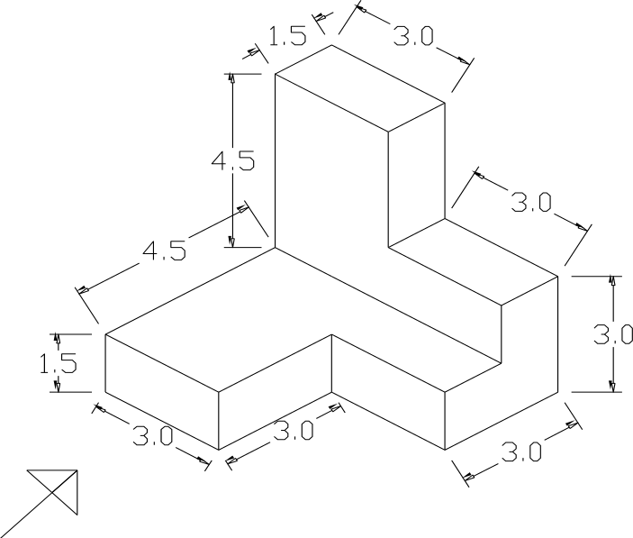

Figure 4.1: Isometric projection

Example 4.2: Draw the given isometric projection (dimensions are in FEET)

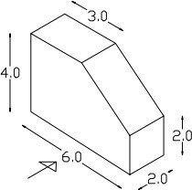

Figure 4.2: Isometric projection

Example 4.3: Draw the given isometric projection (dimensions are in INCH)

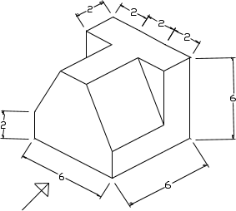

Figure 4.3: Isometric projection

Example 4.4: Draw the given isometric projection (dimensions are in INCH)



Figure 4.4: Isometric projection

Example 4.5: Draw the given isometric projection (dimensions are in INCH)

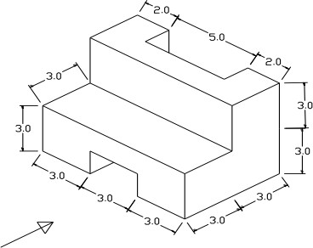

Figure 4.5: Isometric projection

Example 4.6: Draw the given isometric projection (dimensions are in FEET)

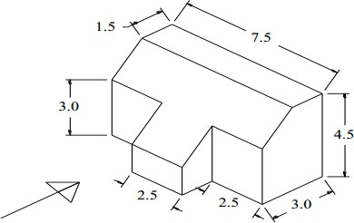

Figure 4.6: Isometric projection

***Reference***

1. David Byrnes and Mark Middlebrook, “AutoCAD 2007 For Dummies”.
2. Jeyapoovan T, “Lesson Plans for Engineering Graphics”.